Name: Kosinapalli Mayuri  
Reg no: 192372104  
Course code: CSA1503 – Cloud computing

**Exp 1:** CREATE A SIMPLE CLOUD SOFTWARE APPLICATION AND PROVIDE IT AS A SERVICE USING ANY CLOUD SERVICE PROVIDER TODEMONSTRATE SOFTWARE AS A SERVICE (SAAS).

**AIM:** To create a simple cloud software application and provide it as a service using any cloud service provider to demonstrate software as a service (saas).

PROCEDURE:

STEP1: GOTO ZOHO.COM

STEP 2: LOGIN TO THE ZOHO.COM

STEP 3: SELECT ONE APPLICATION

STEP 4: ENTER APPLICATION NAME

STEP 5: CREATED NEW APPLICATION

STEP 6: SELECT ONE FORM

STEP 7: THE SOFTWARE HASE BEEN CREATED.

**IMPLEMENTATION:**

1. **Login into zoho app and access zoho creator**

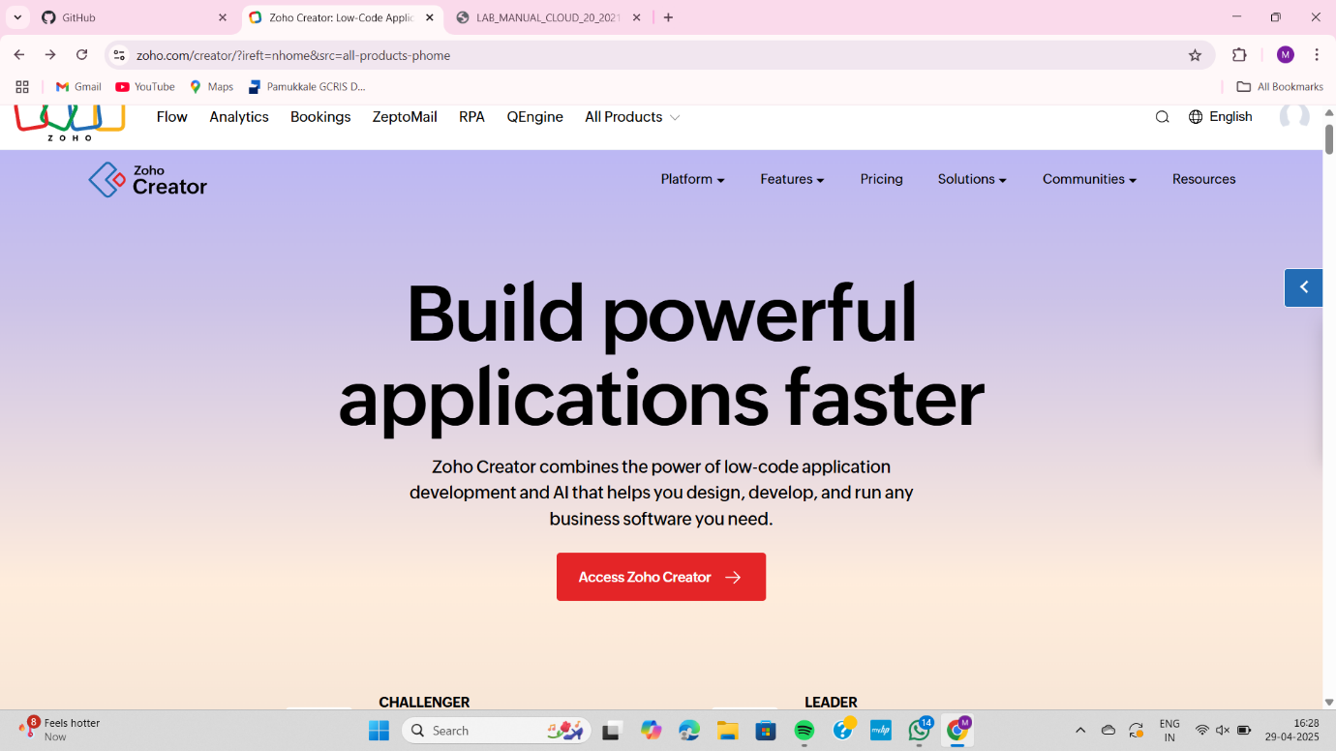

1. **Create a application**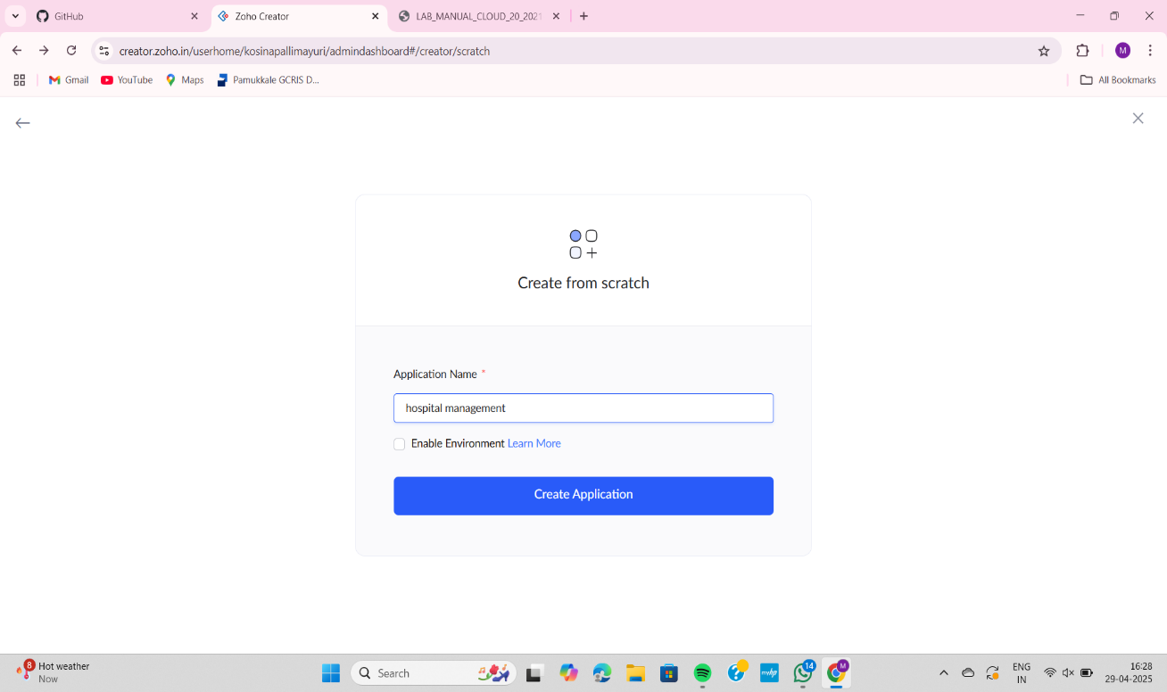

**3) click on forms and create from scratch**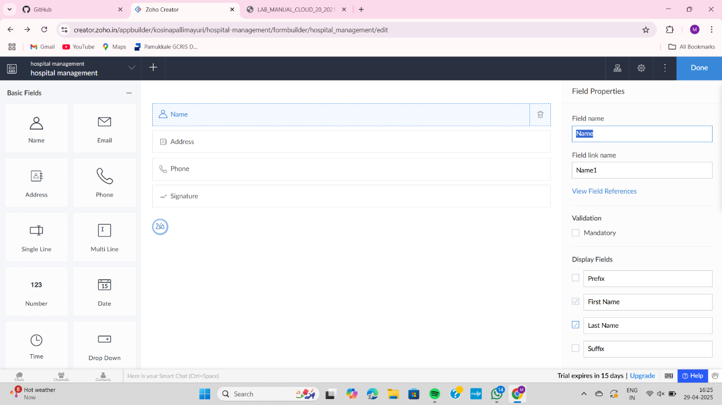

**4)fill the patient details**

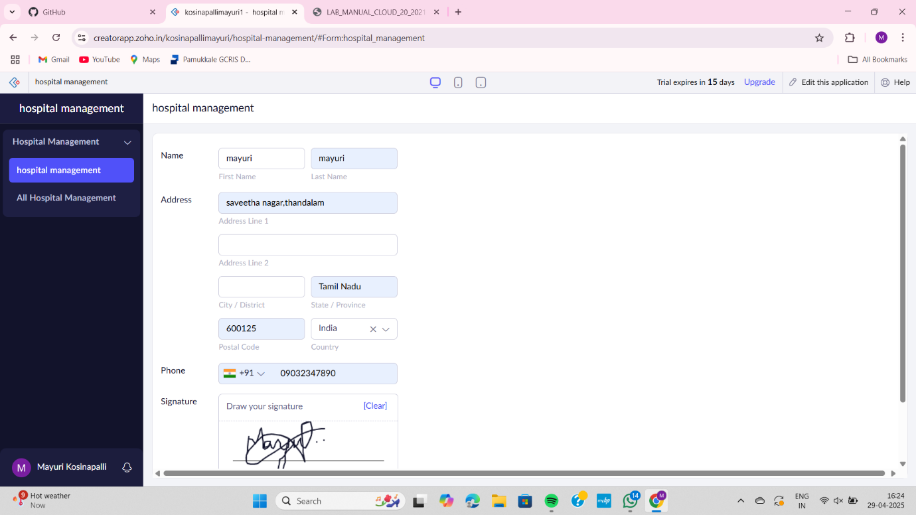

**5) display the details**

